**Stat 534 HW6**

Jeffrey Lee

1826649

Problem1.

(b)

J = 0.2 can’t put it in one picture, so I divided into various part.

Part 1 Part 2

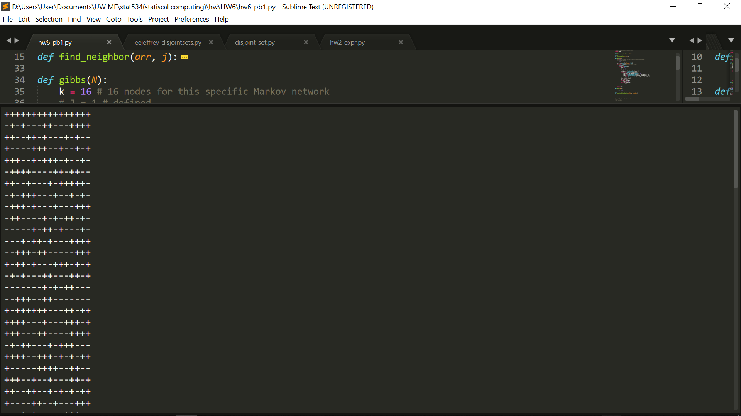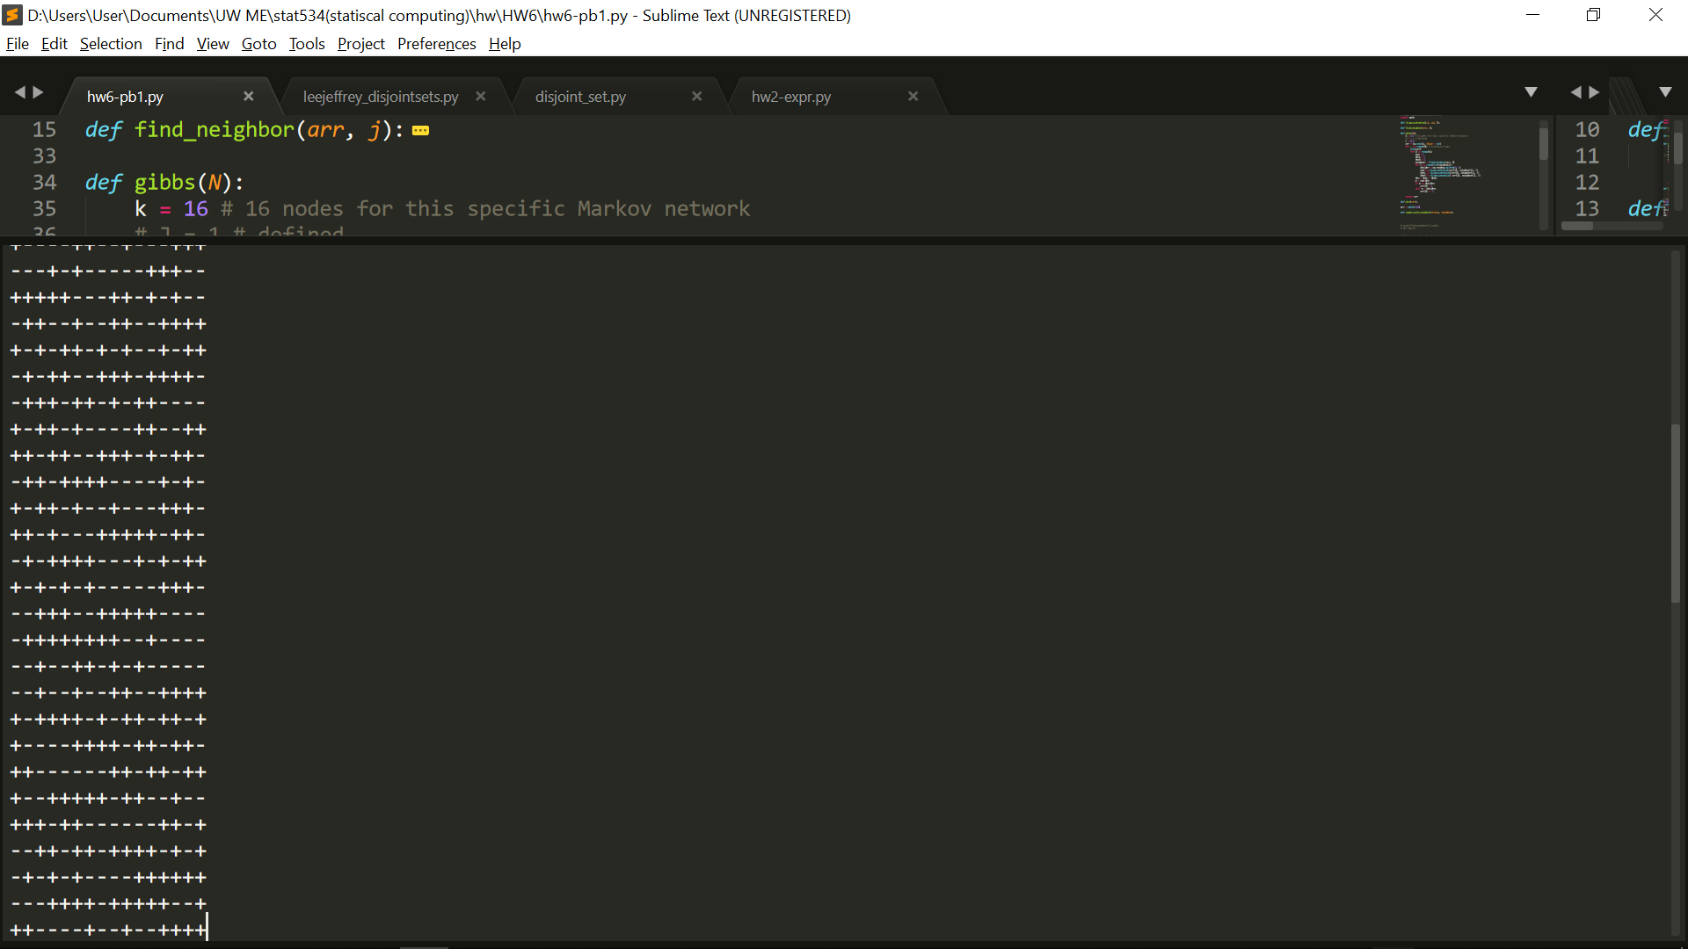

Part 3 Part 4

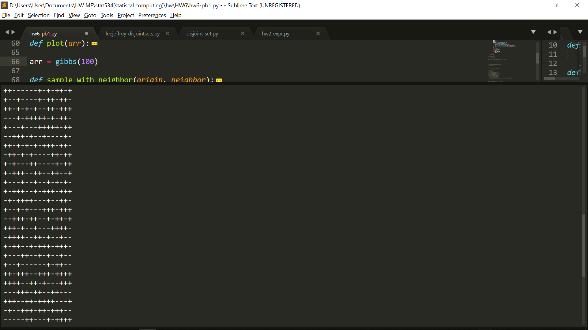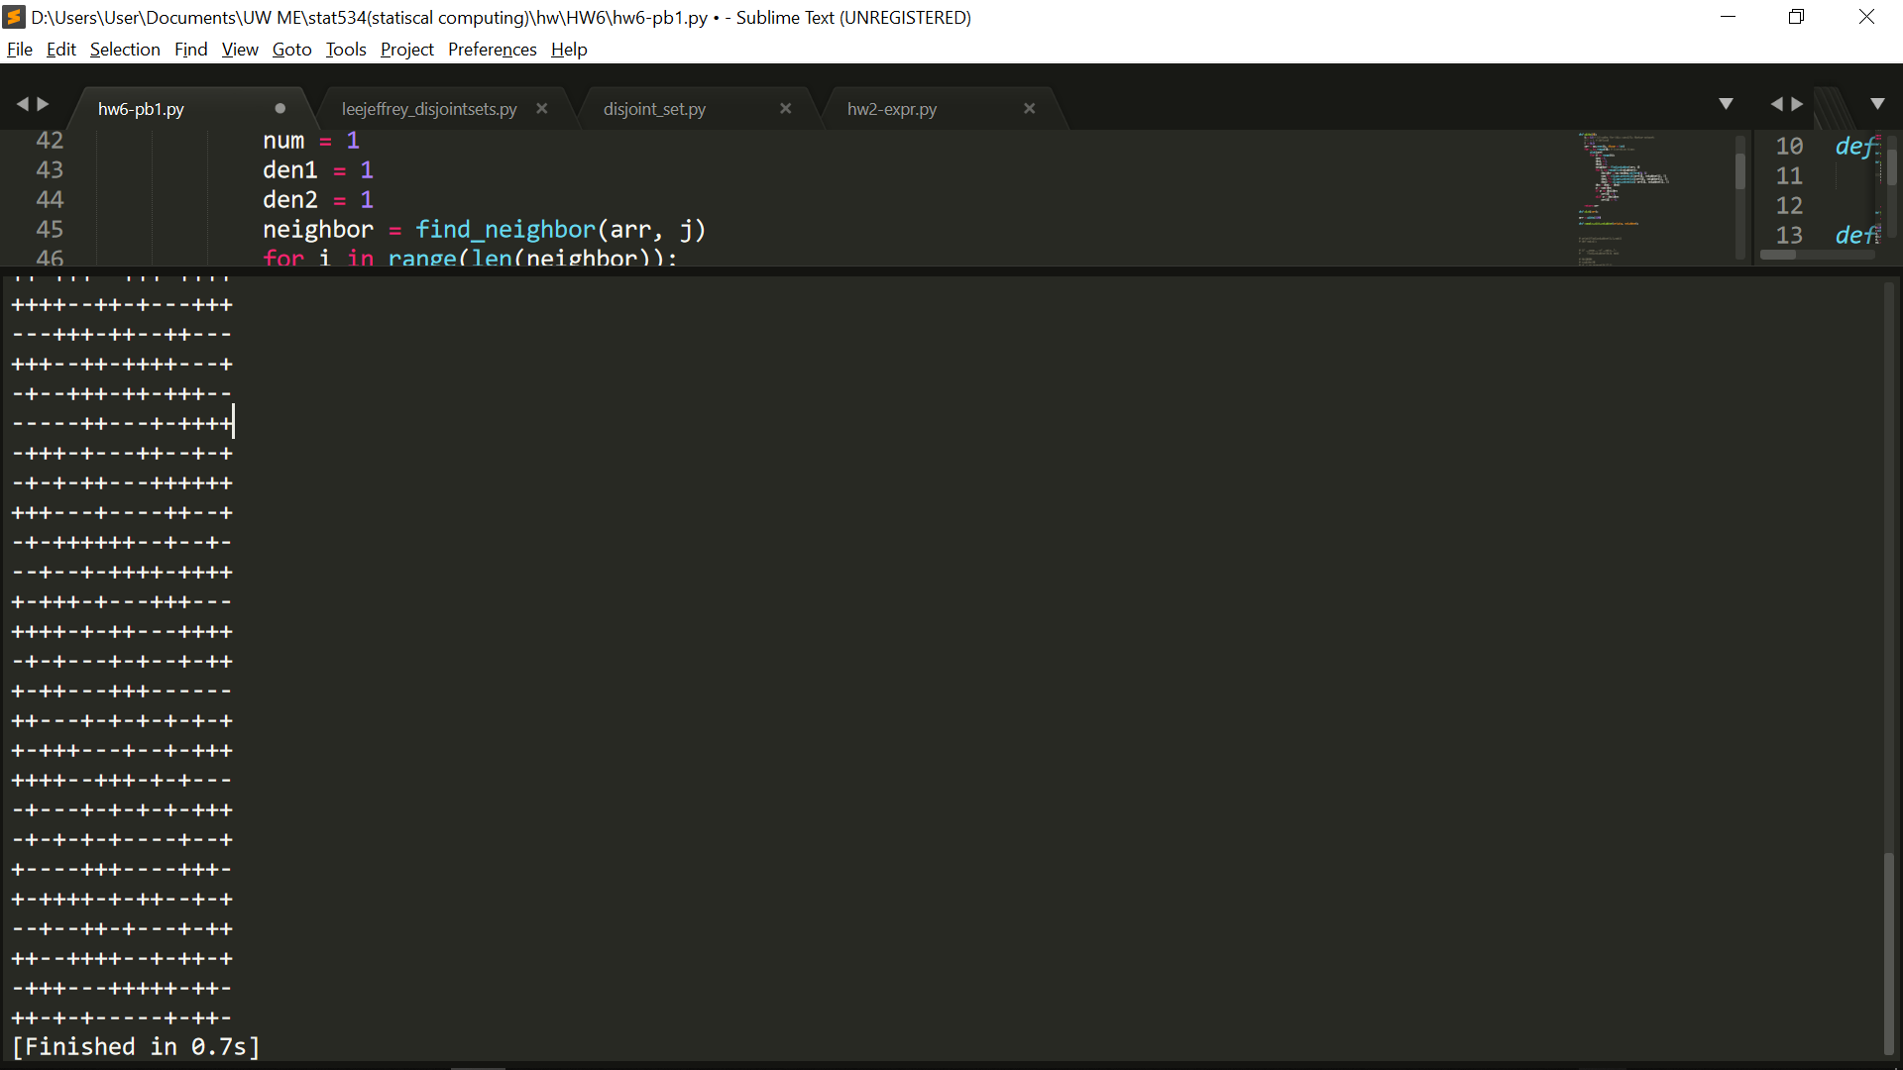

J = 1

Part 1 Part 2

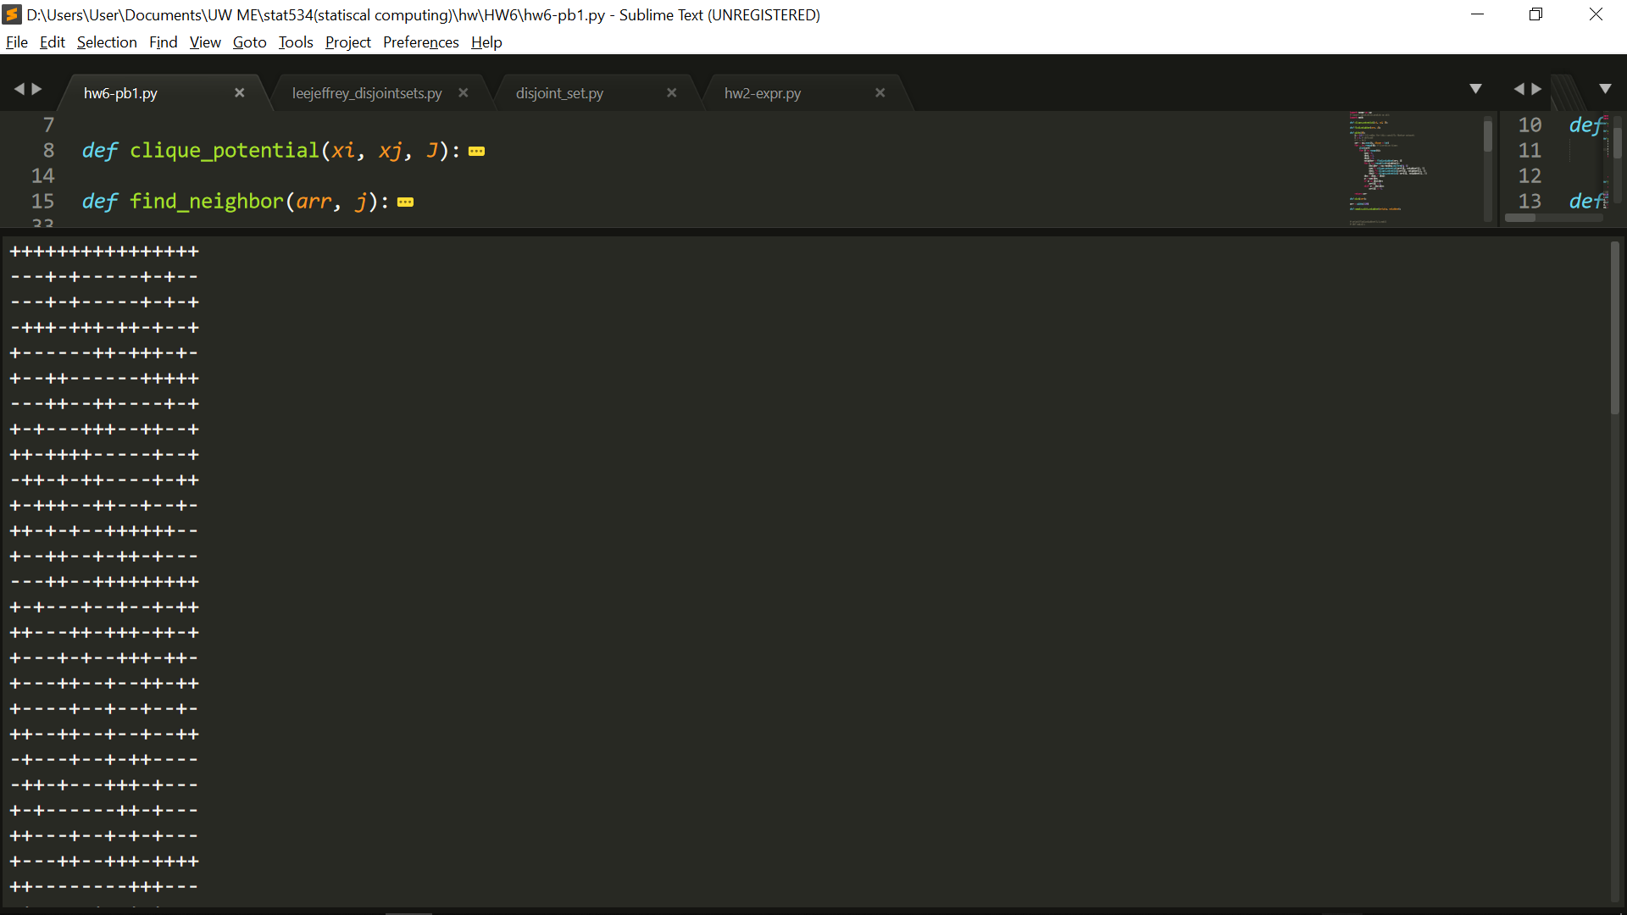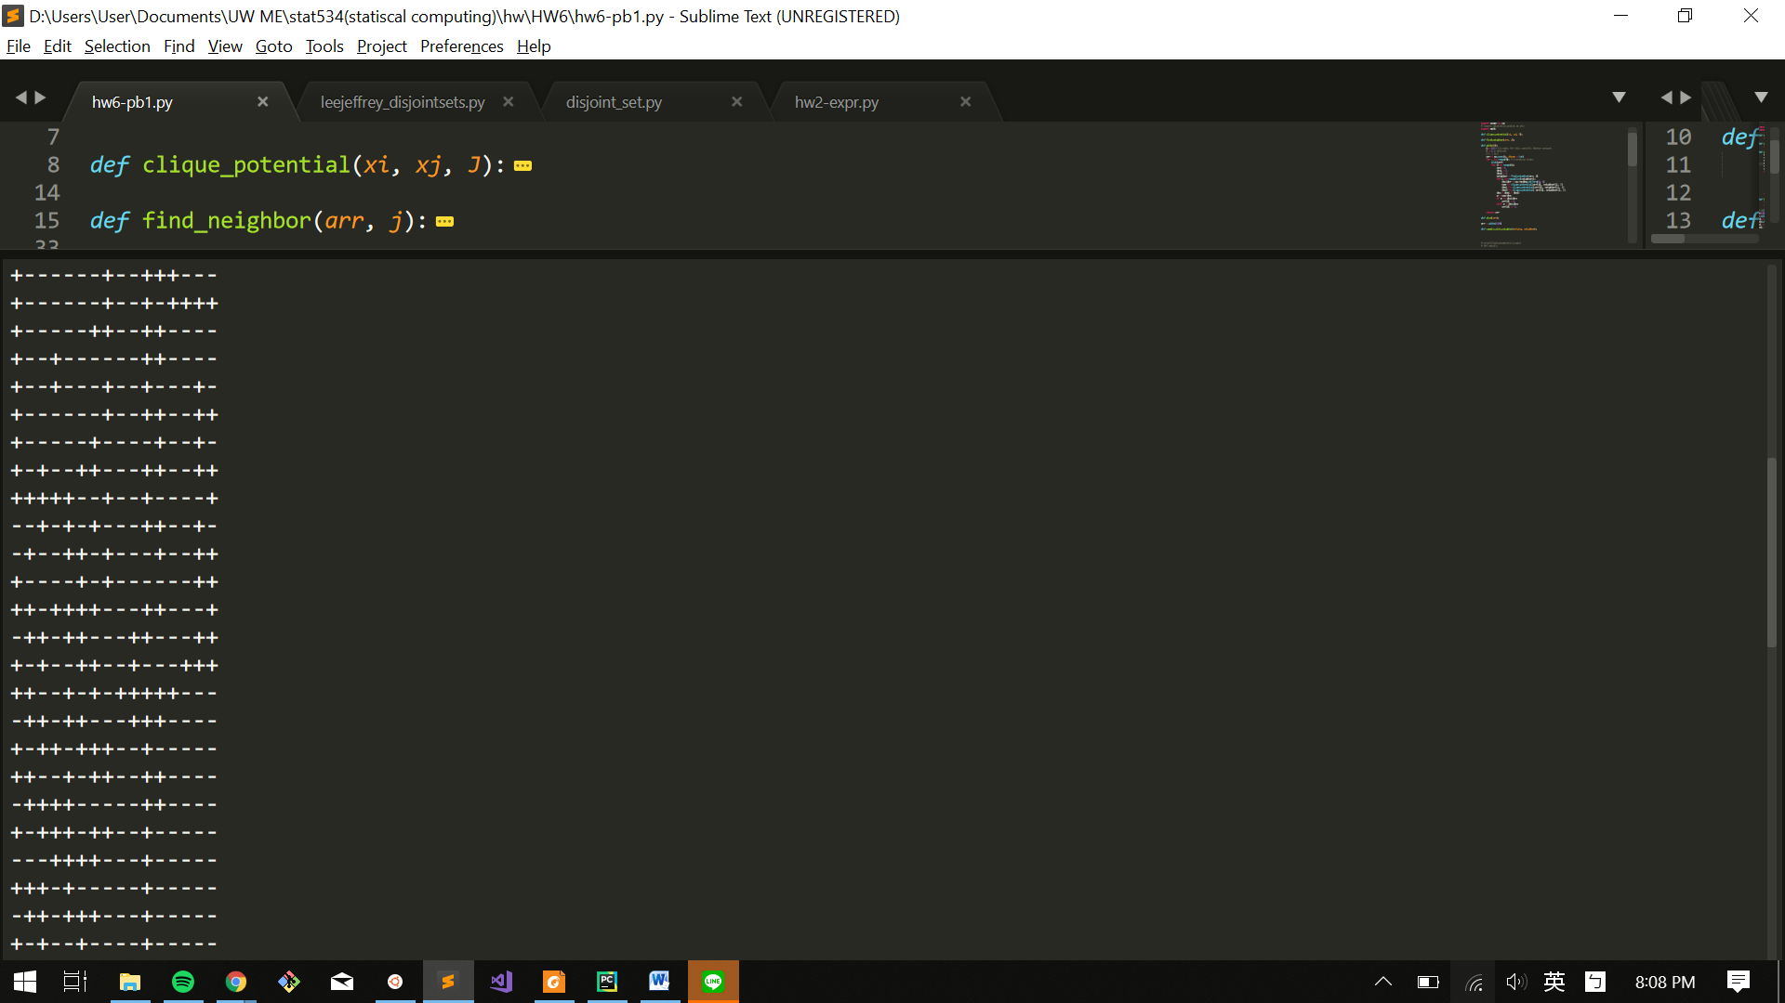

Part 3 Part 4

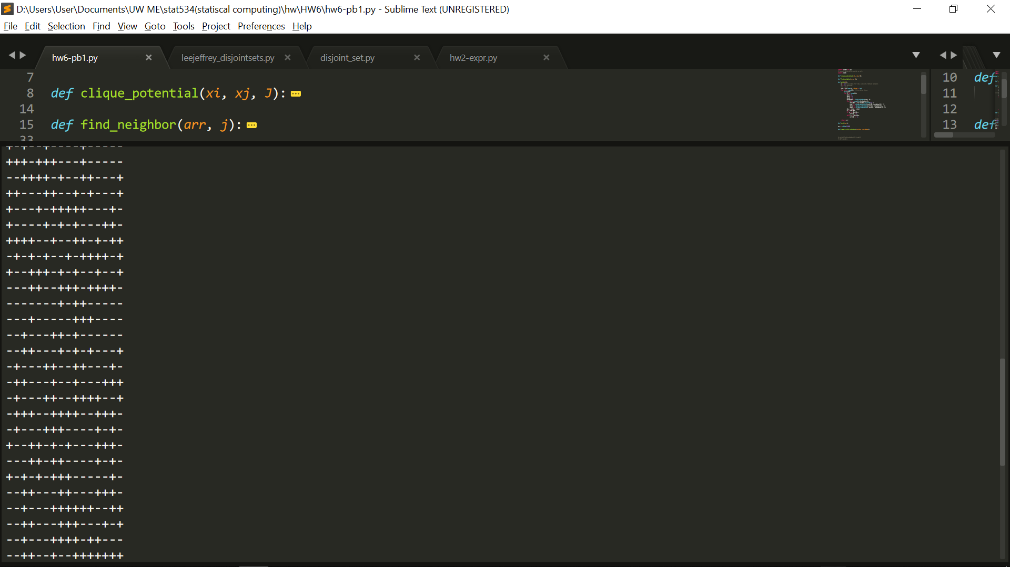`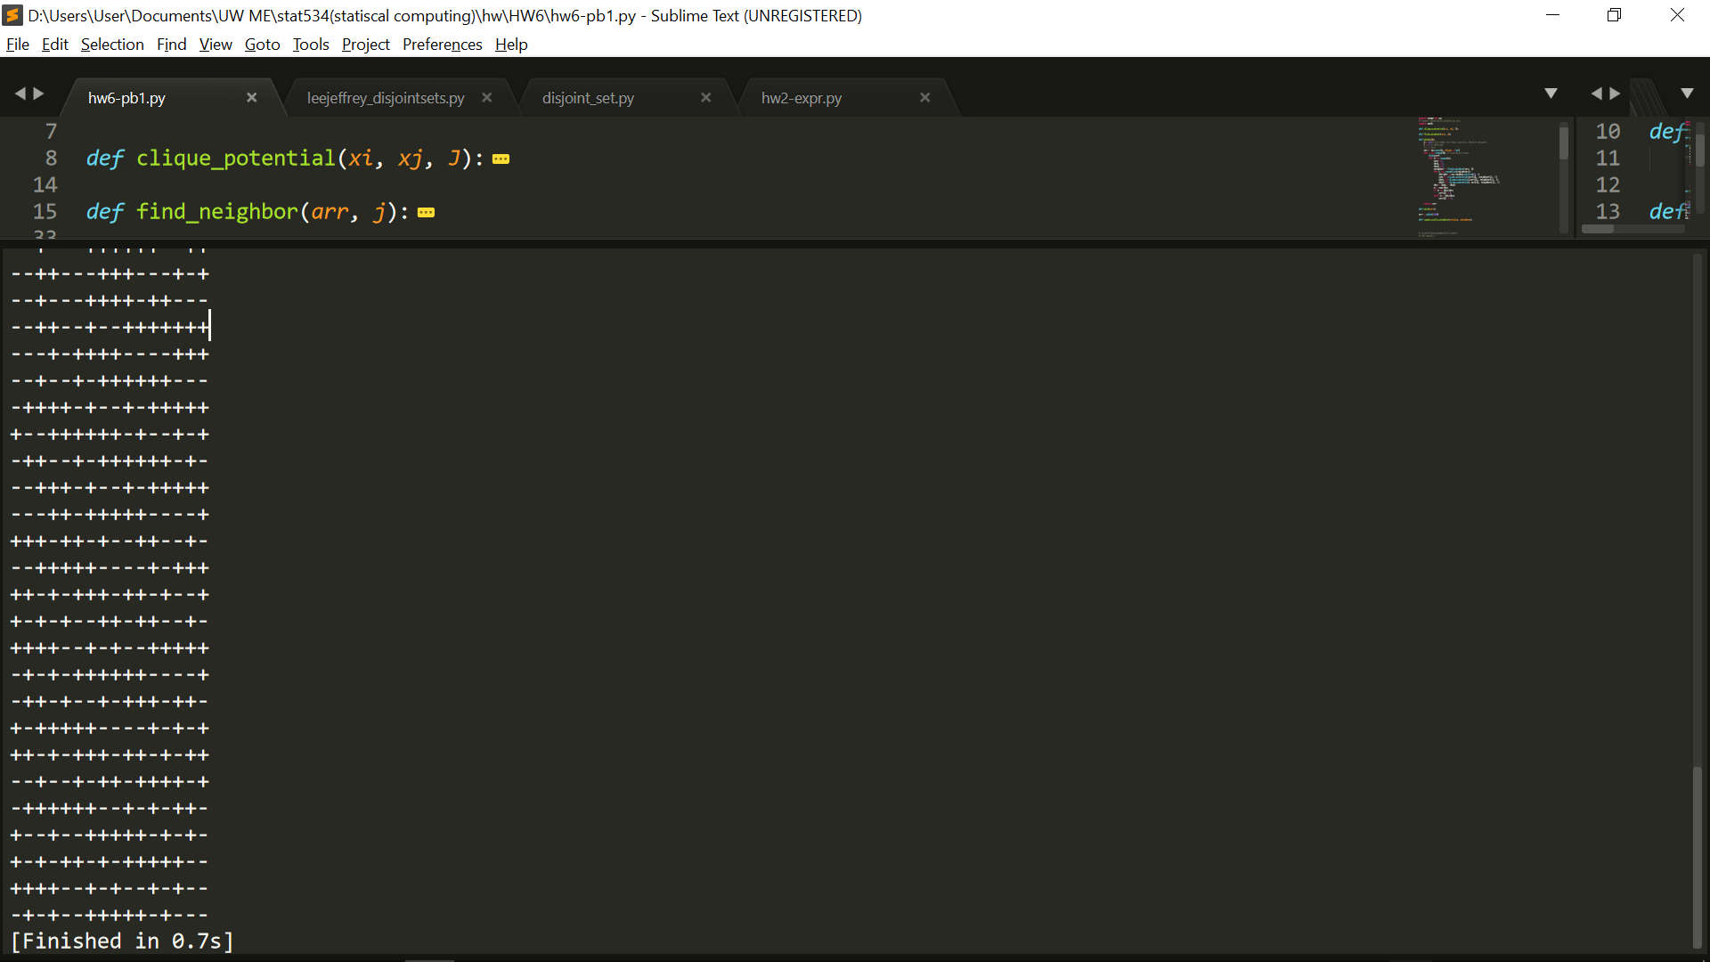

c.

J = 0.2

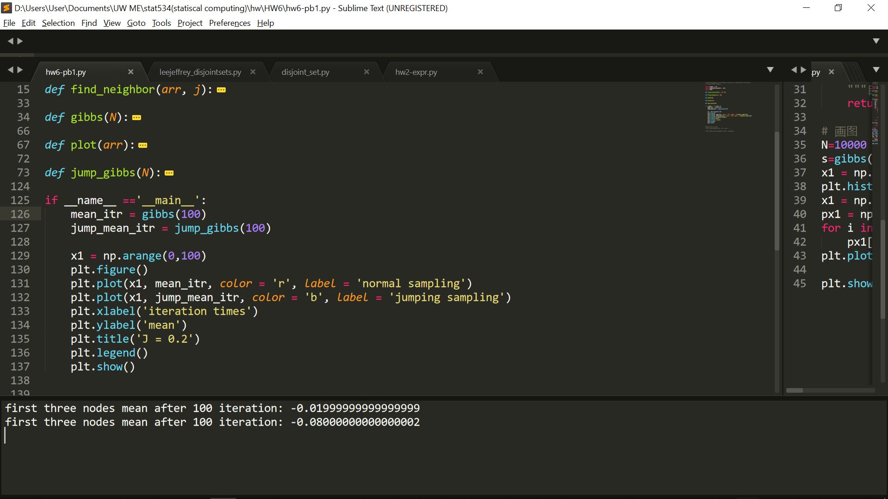

J = 1

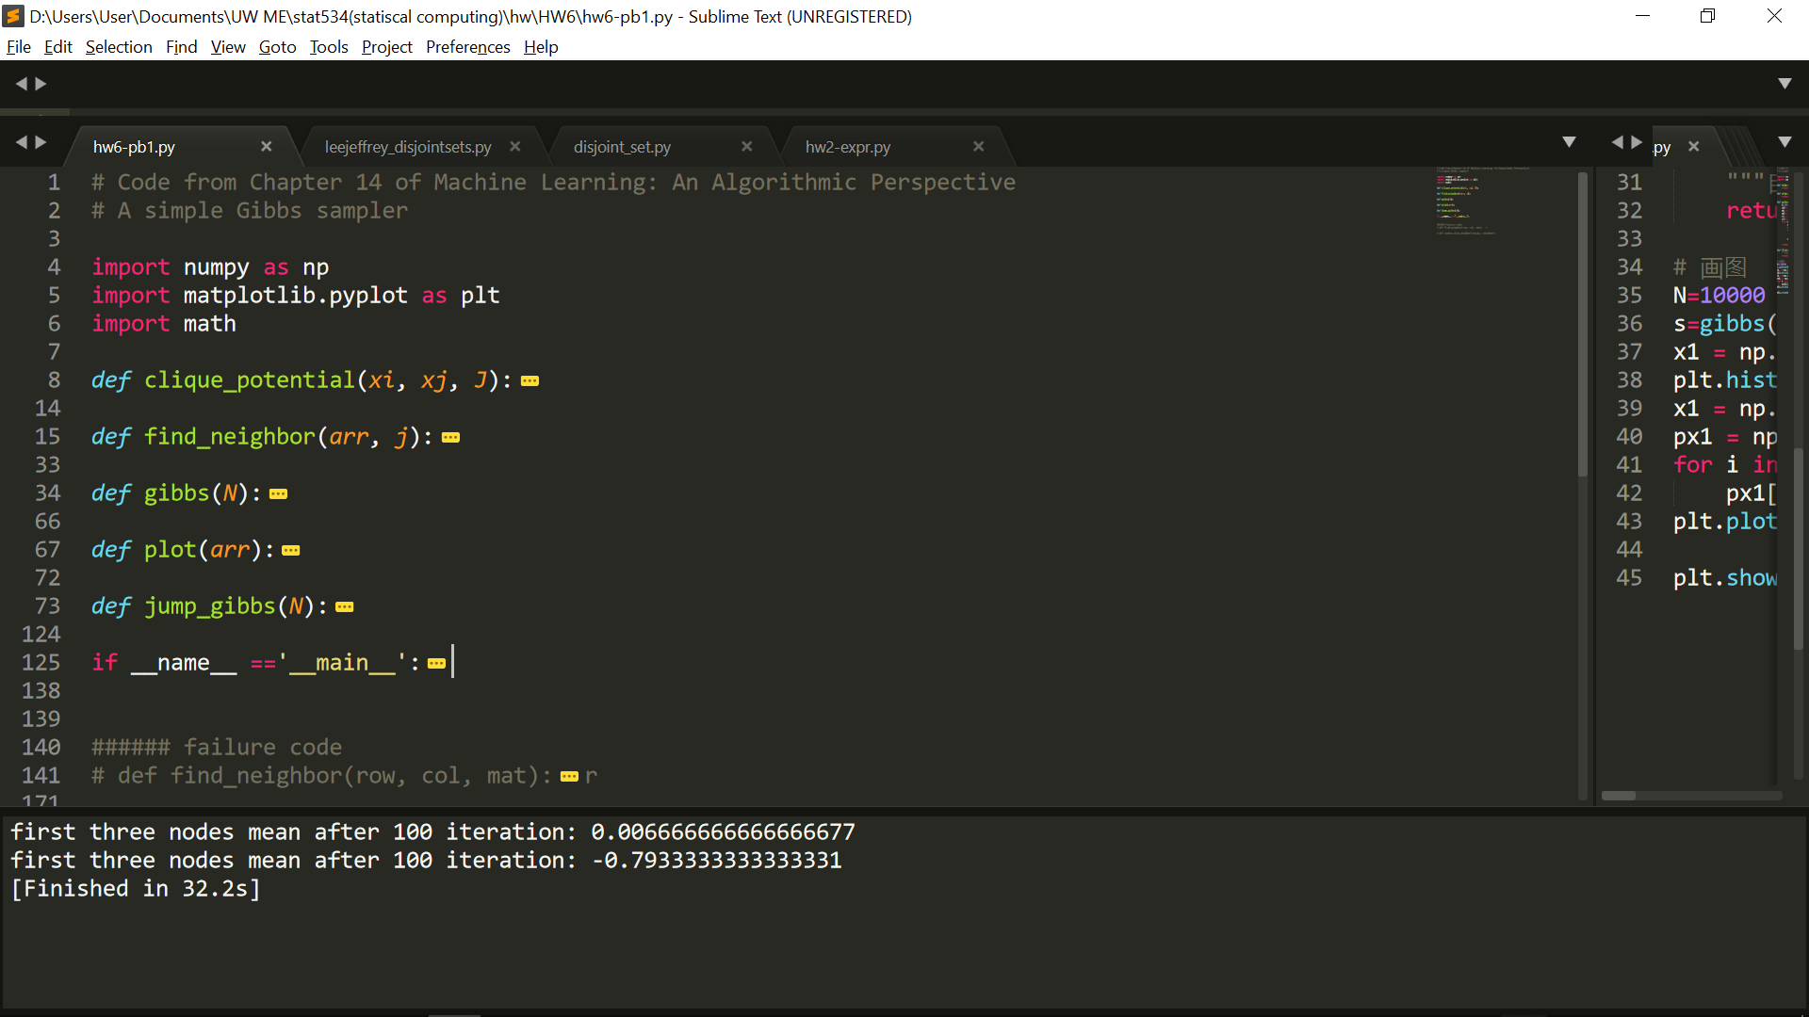

d. e.

J = 0.2

Part 1 Part 2

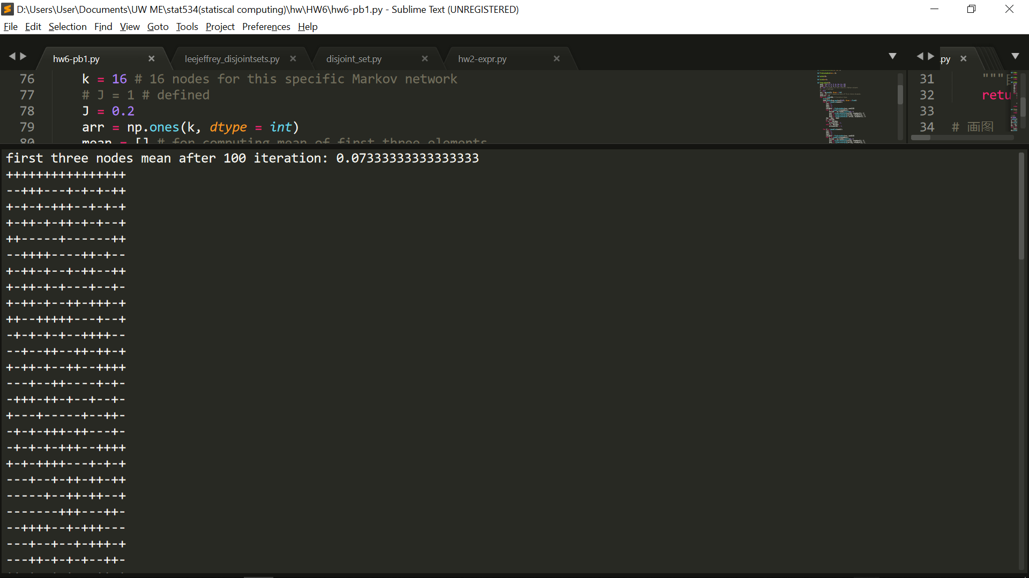 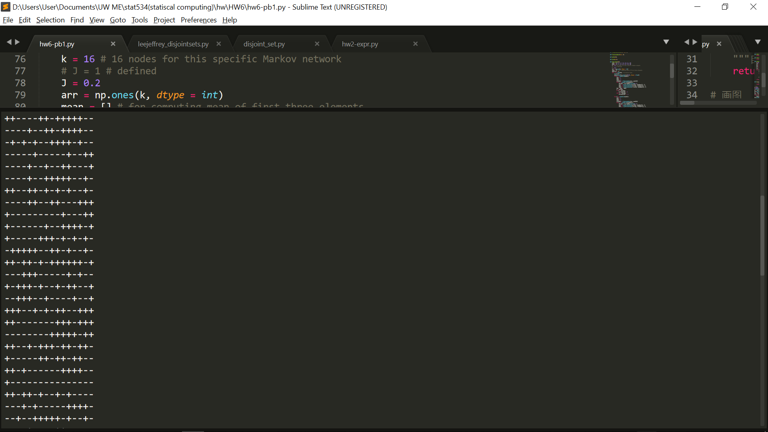

Part 3 Part 4

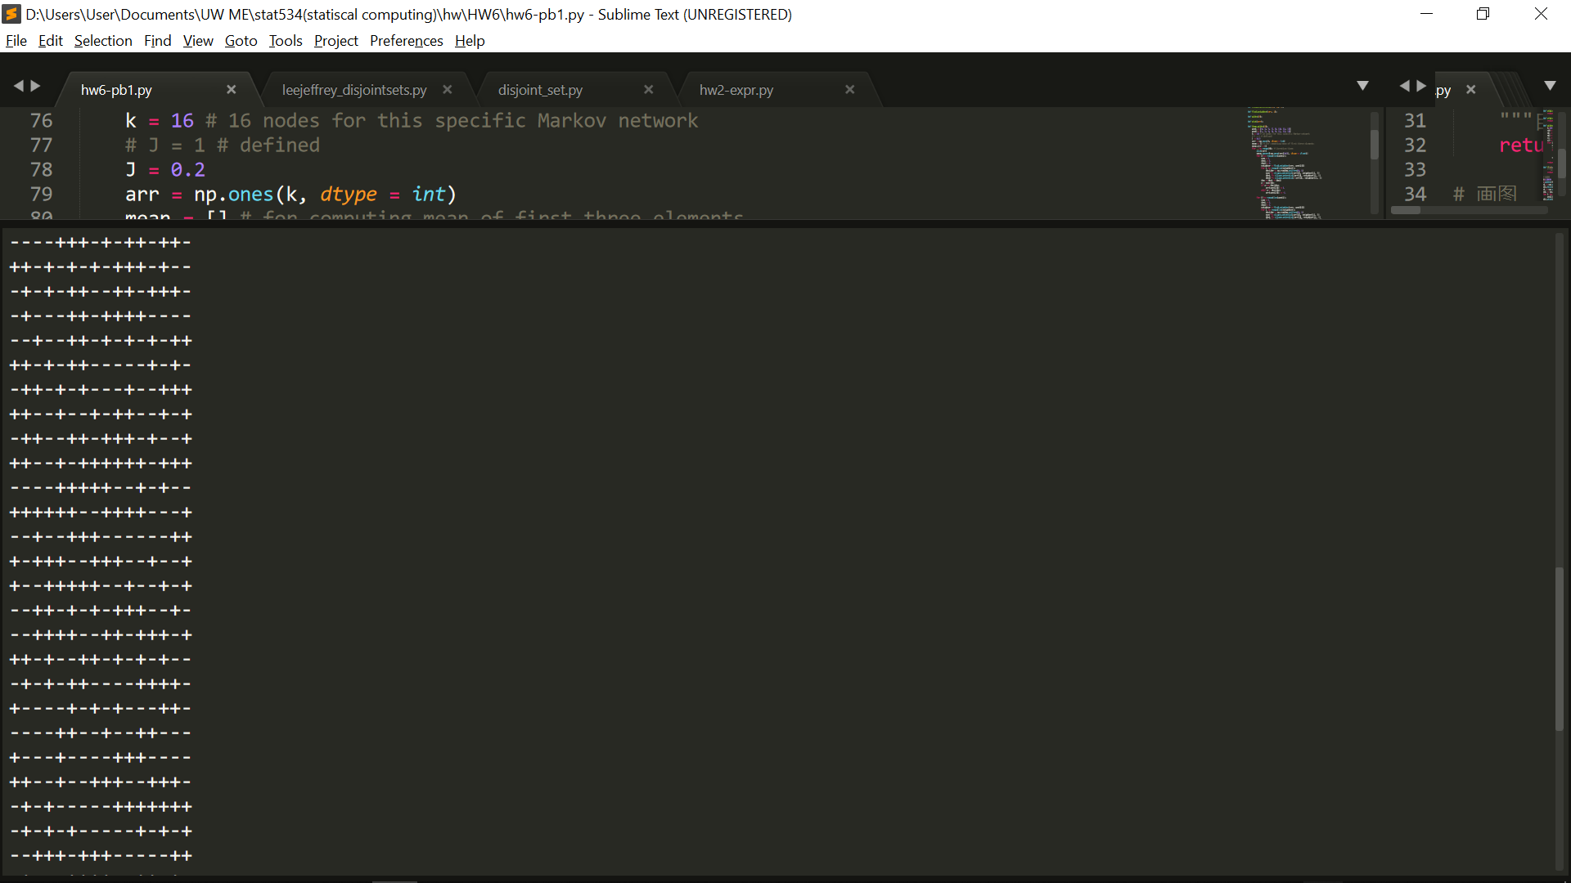 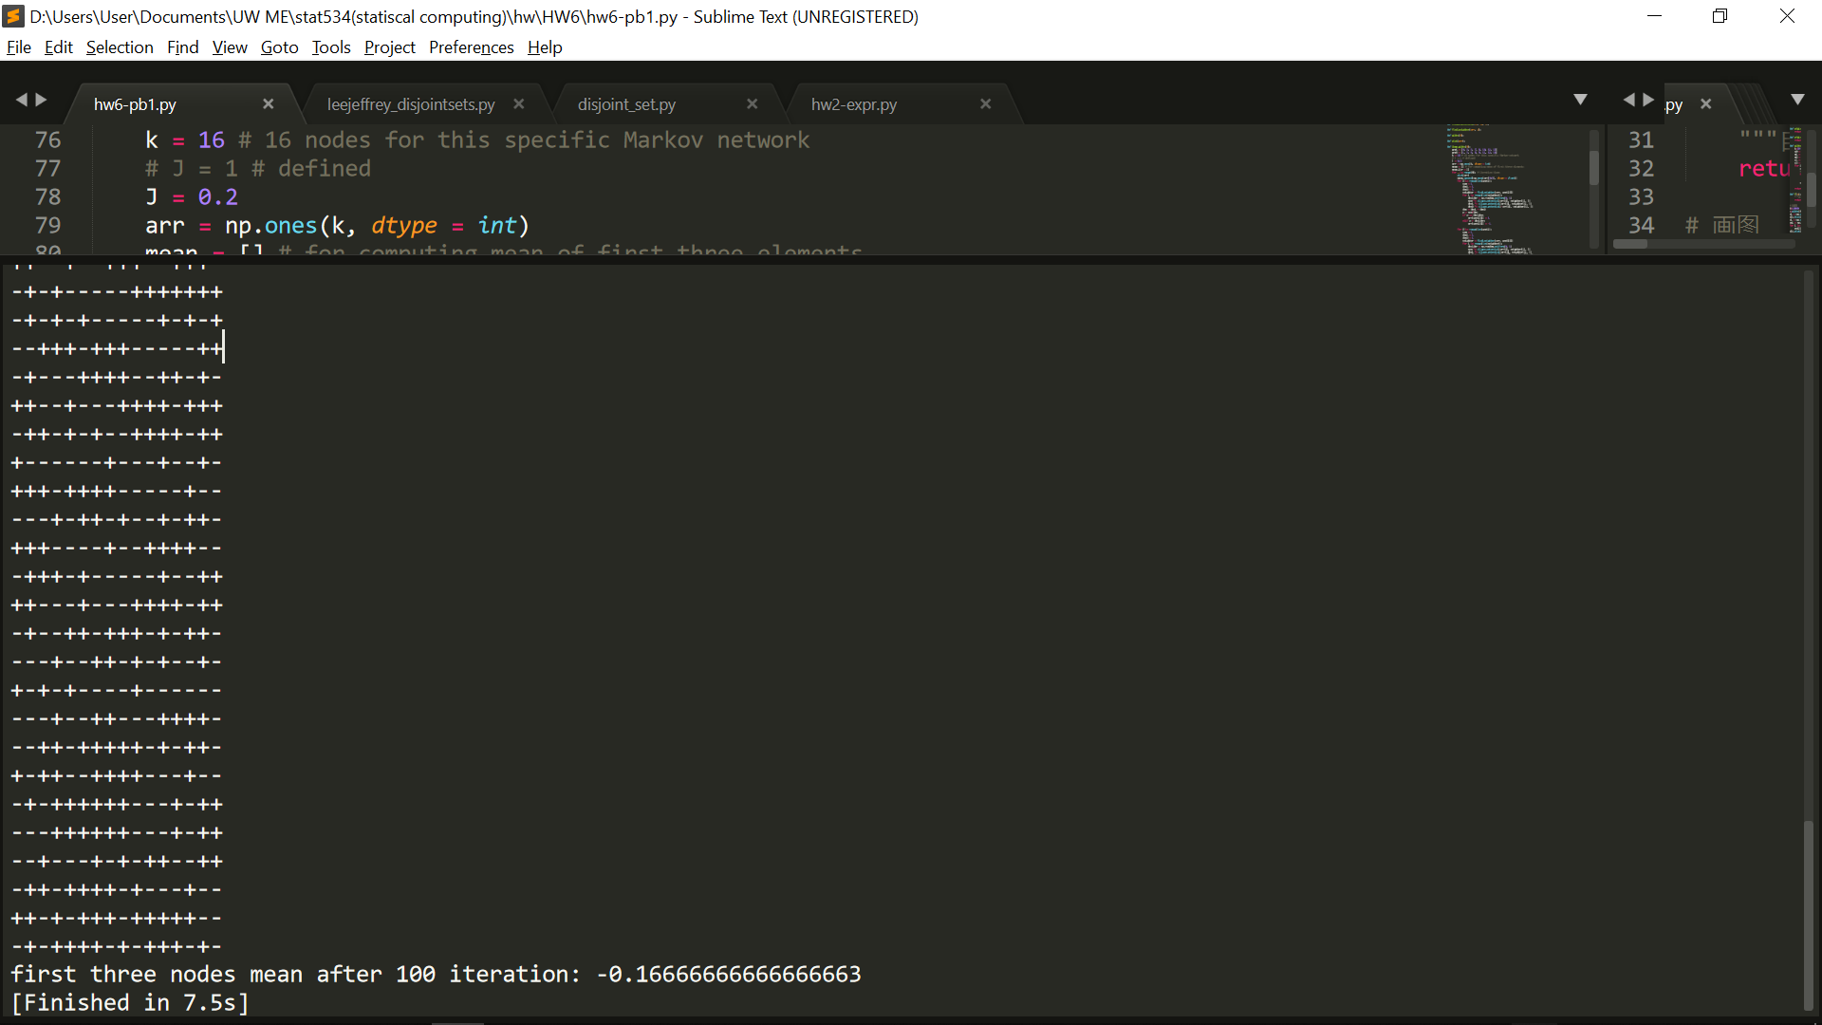

J = 1

Part 1 Part 2

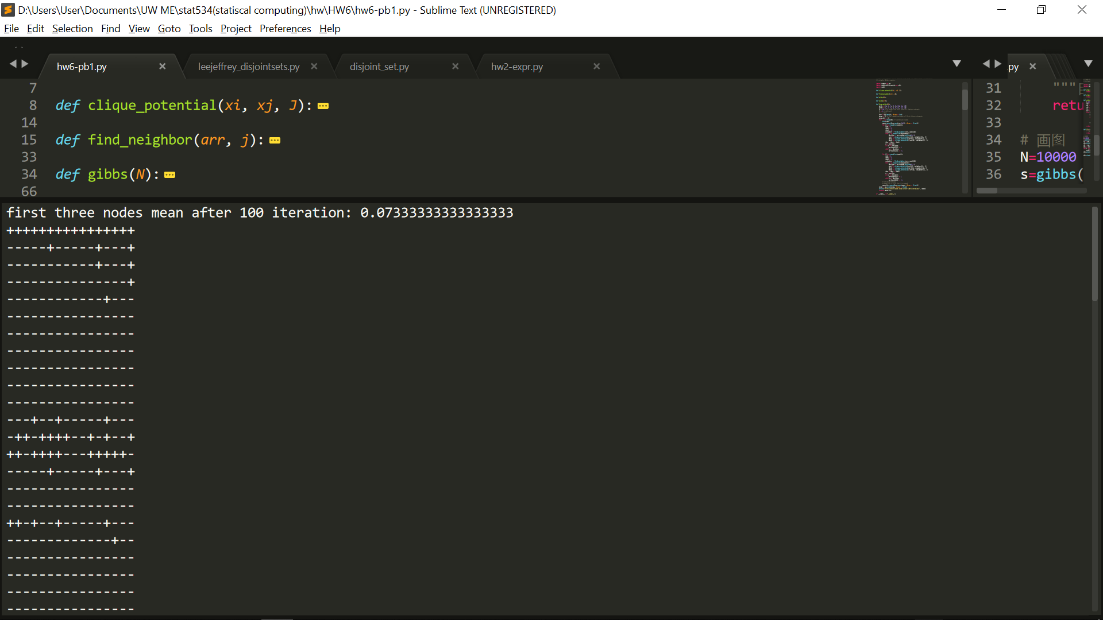 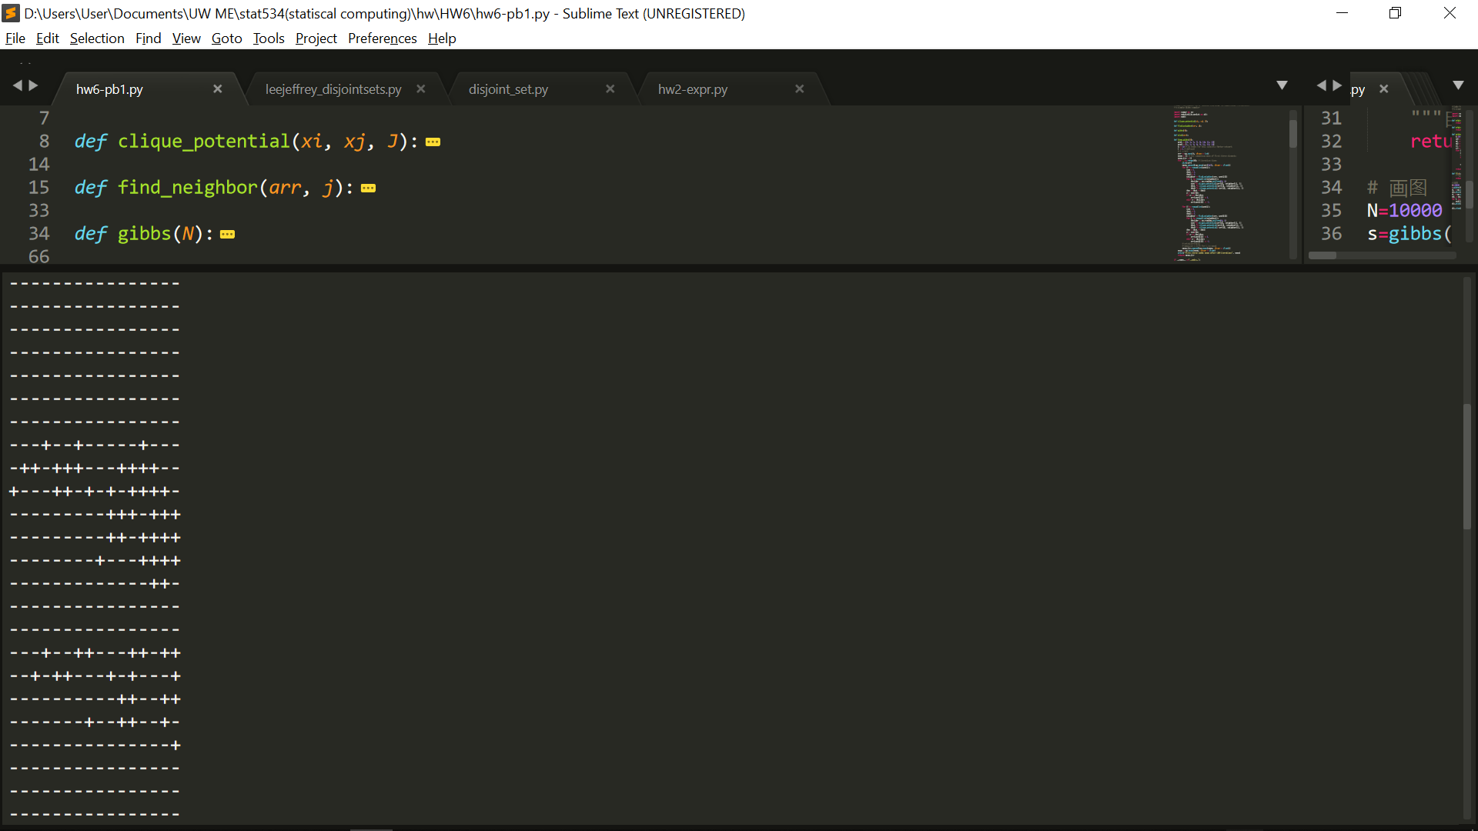

Part 3 Part 4

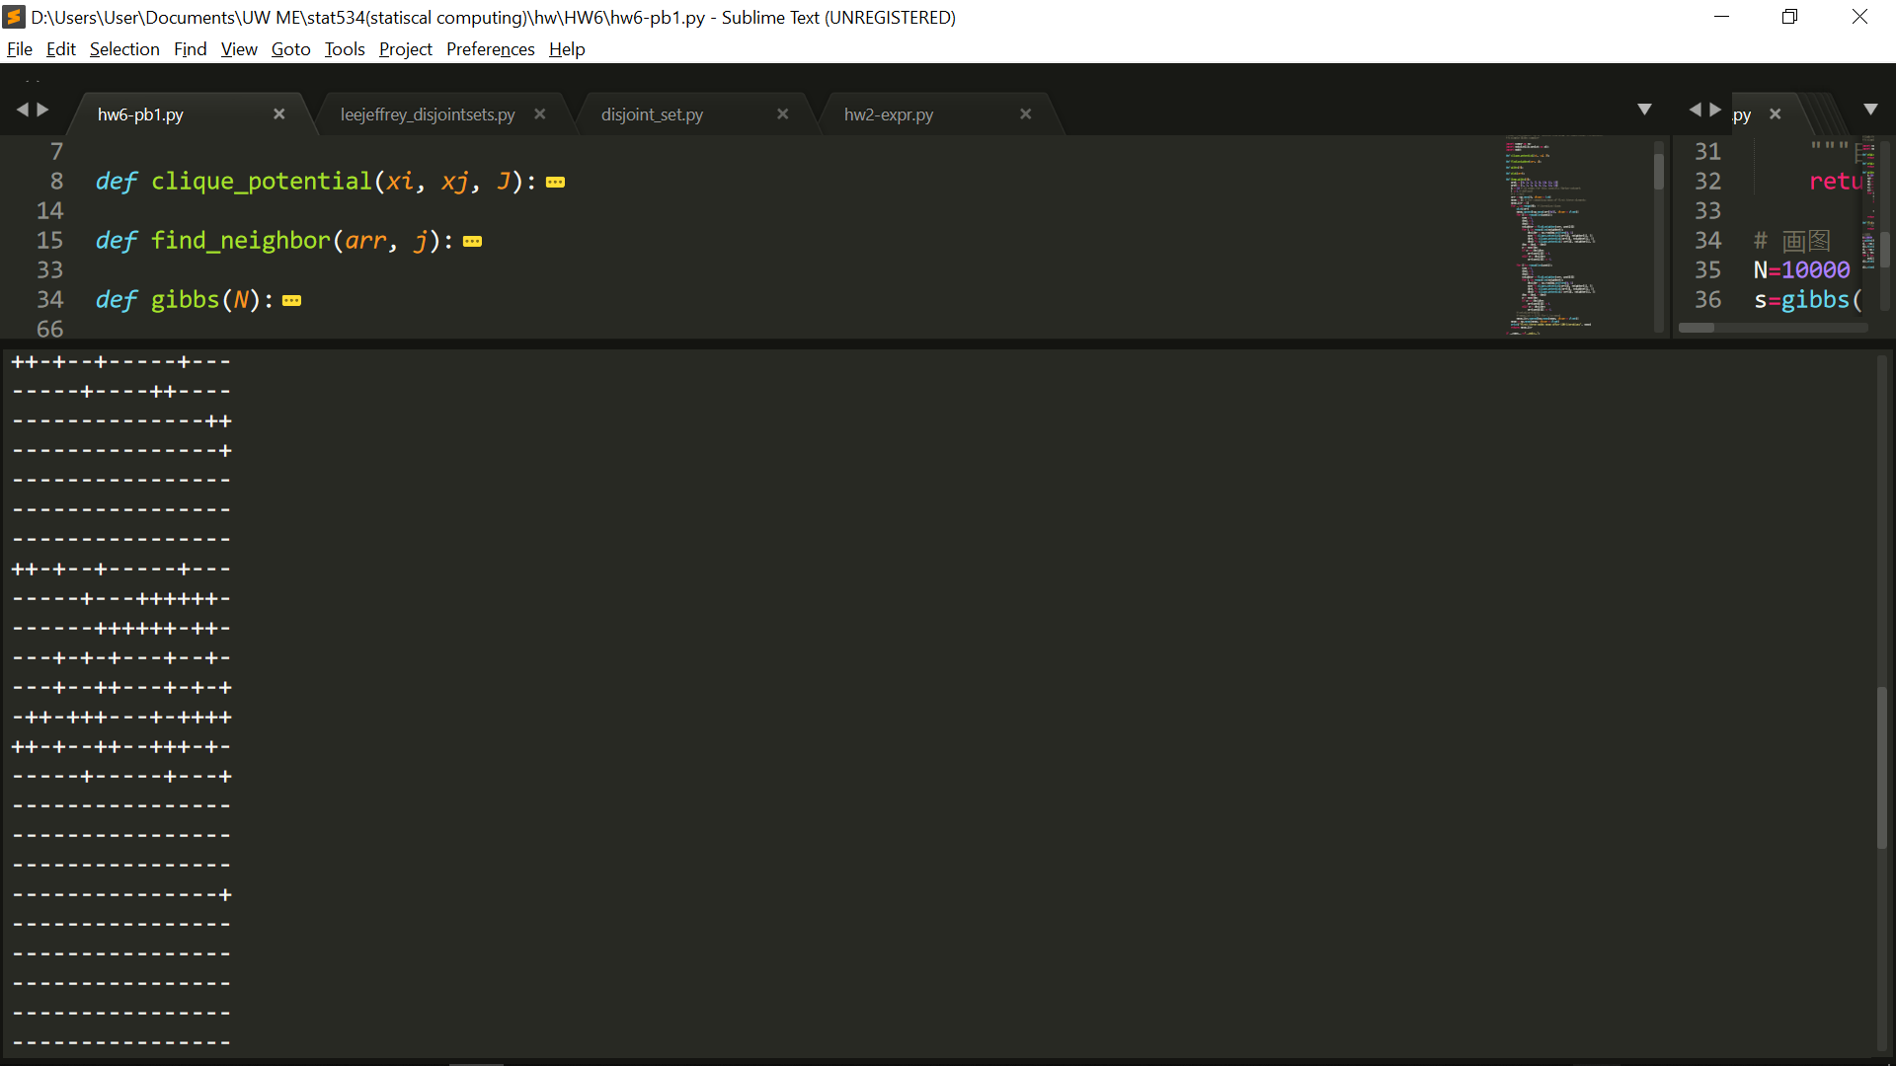 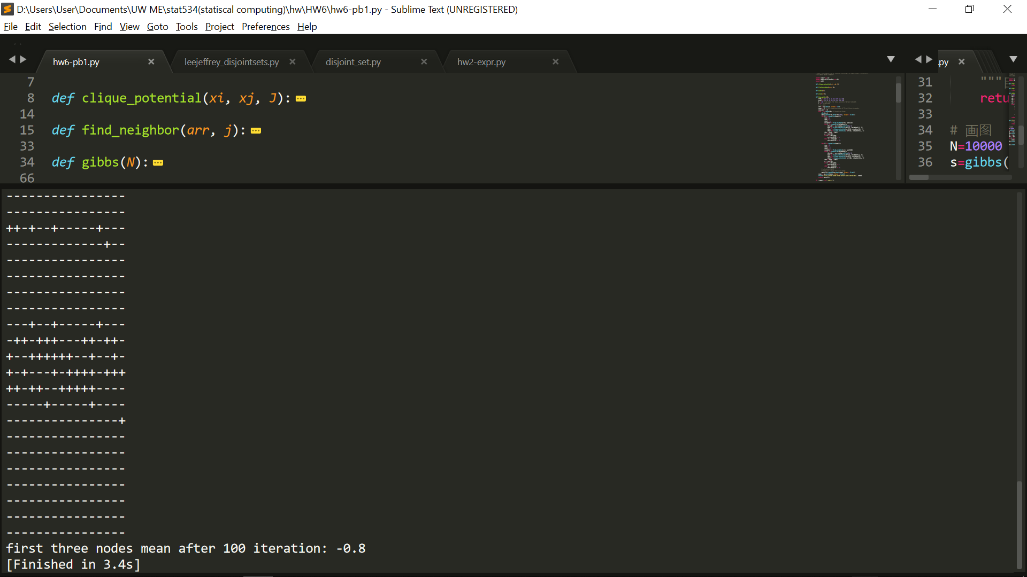

J = 0.2

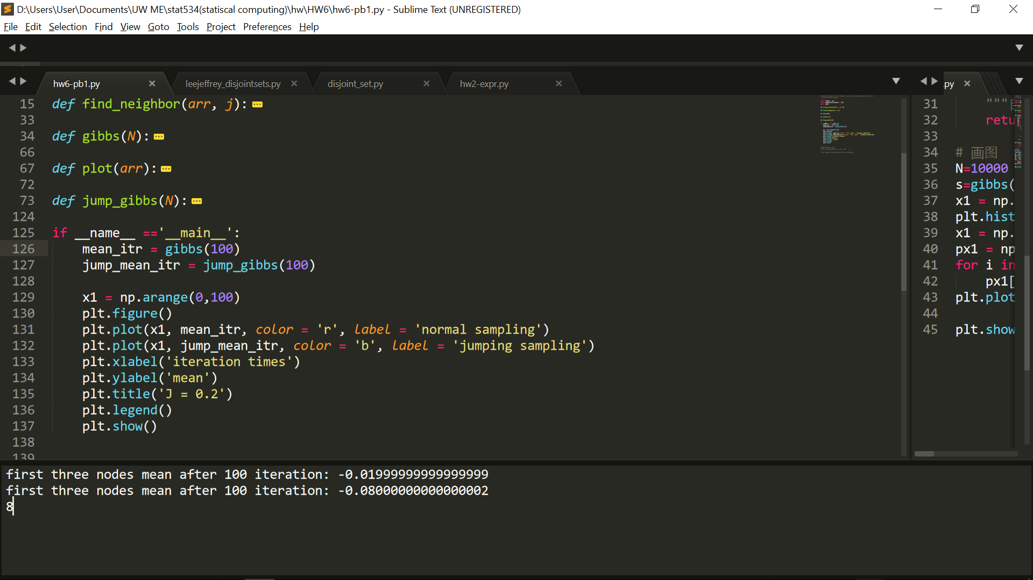

J = 1



f.

Either J equals 1 or 0.2, the normal gibbs sampling will converge faster, since gibbs sampling depends on the updated data from each iteration. After we get the new sampling data, we use the new data to sample next point. However, the jumping sampling method will deprive the dependency of each node and will sample from the old data point. This can also be shown from the figures below. When J equals to 1, the sampling data will even more like diverge and will not come close to 0 as what we expected.

